**Employee Management System SQL Exercises**

**Departments Table**

CREATE TABLE Departments (

DepartmentID INT PRIMARY KEY,

DepartmentName VARCHAR(100)

);

**Employees Table**

CREATE TABLE Employees (

EmployeeID INT PRIMARY KEY,

FirstName VARCHAR(50),

LastName VARCHAR(50),

DepartmentID INT FOREIGN KEY REFERENCES Departments(DepartmentID),

Salary DECIMAL(10,2),

JoinDate DATE

)

INSERT INTO Departments (DepartmentID, DepartmentName) VALUES

(1, 'HR'),

(2, 'Finance'),

(3, 'IT'),

(4, 'Marketing')

INSERT INTO Employees (EmployeeID, FirstName, LastName, DepartmentID, Salary,

JoinDate) VALUES

(1, 'John', 'Doe', 1, 5000.00, '2020-01-15'),

(2, 'Jane', 'Smith', 2, 6000.00, '2019-03-22'),(3, 'Michael', 'Johnson', 3, 7000.00, '2018-07-30'),

(4, 'Emily', 'Davis', 4, 5500.00, '2021-11-05');

**DEPARTMENTS TABLE**

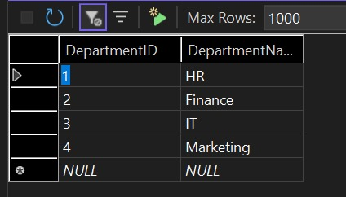

**EMPLOYEES TABLE**

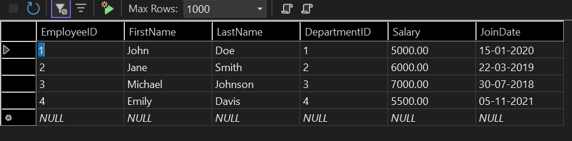

CREATE PROCEDURE sp_GetEmployeesByDepartment

@DepartmentID INT

AS

BEGIN

SELECT

E.EmployeeID,

E.FirstName,

E.LastName,

D.DepartmentName,

E.Salary,

E.JoinDate

FROM Employees E

INNER JOIN Departments D ON E.DepartmentID = D.DepartmentID

WHERE E.DepartmentID = @DepartmentID;

END;

EXEC sp_GetEmployeesByDepartment @DepartmentID = 2;

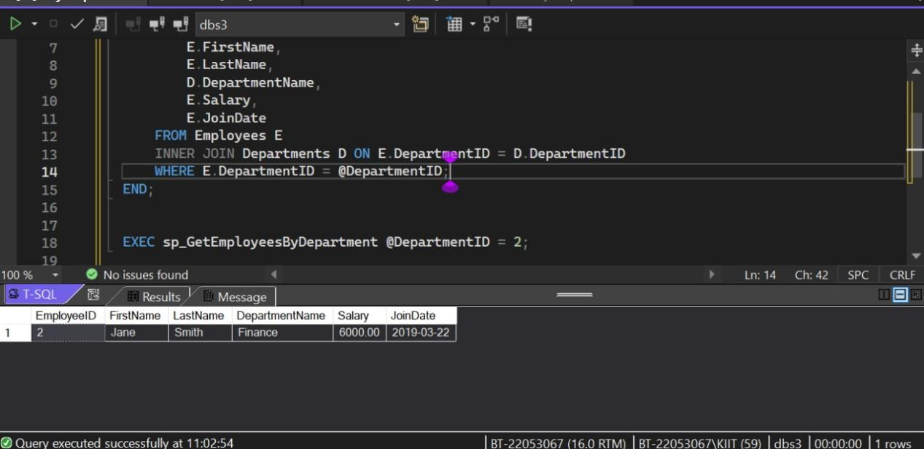

CREATE PROCEDURE sp_InsertEmployee

@FirstName VARCHAR(50),

@LastName VARCHAR(50),

@DepartmentID INT,

@Salary DECIMAL(10,2),

@JoinDate DATE

AS

BEGIN

INSERT INTO Employees (FirstName, LastName, DepartmentID, Salary, JoinDate)

VALUES (@FirstName, @LastName, @DepartmentID, @Salary, @JoinDate);

END;

**Example:**

EXEC sp_InsertEmployee

@FirstName = 'Alice',

@LastName = 'Williams',

@DepartmentID = 3,

@Salary = 7200.00,

@JoinDate = '2022-06-01';

